Another function of SHAP that helped us during this project is the function to see the interpretability of the features in each values of our predictions. Value 1 might be positive as value 20, but the impact of the features has a different impact. Here I will show the interpretability of the features on one value.

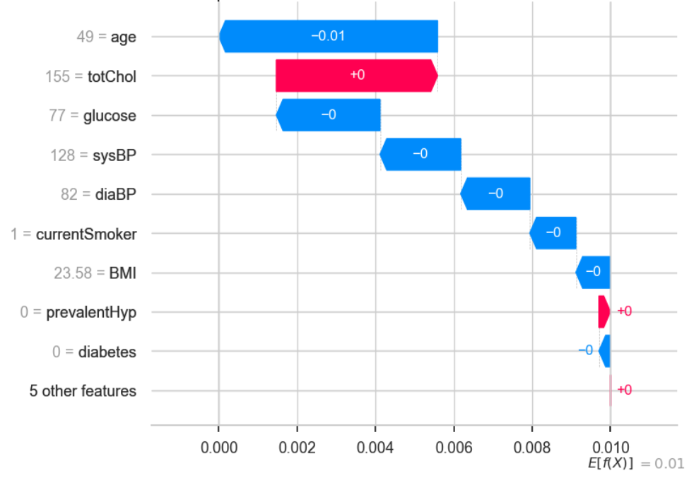

Figure 20 – Shap Value 1

This plot shows us what are the main features affecting the prediction of a single observation, and the magnitude of the SHAP value for each feature. What we can see here is that age and totChol are the features with more impact in this scenario. If we remember, glucose should be the feature with the most of the importance in the model but we here in this example that age impacts more in the prediction. Let’s look for another value and compare.

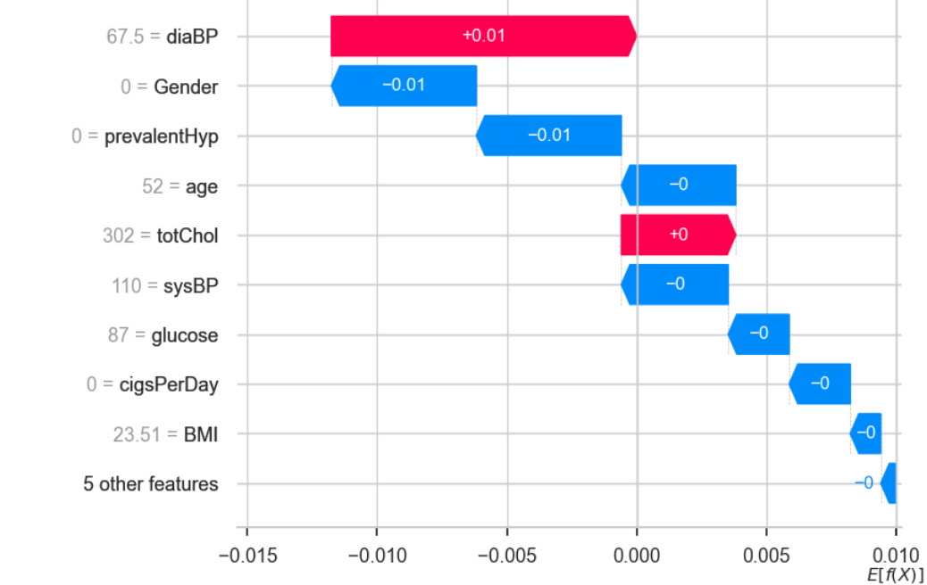

21 – Main features and shap magnitude

In this scenario, we see different features generating different impacts on the prediction.